Research Project: | Teens’ Personal Accounts on Sleep
Investigators: | Dr Dagmara Dimitriou, Georgia Pavlopoulou, Vasiliki Matella: Lifespan Learning and Sleep Laboratory, UCL

With all the distractions of the modern world, have you ever wondered about how well your teen sleeps? And what happens if they do not get a good night of sleep? At Lilas Lab, based at the Institute of Education, UCL we are trying to find out. This study aims to gather information about the relationship between sleep, wellbeing and social media. We would like to understand what factors might pose a positive or negative influence on sleep.
You may choose to participate only in the survey and missing puzzle test or complete all stages and get a £5 AMAZON voucher and a free sleep report that shows how your sleep works.

Please read the information below and return the last page completed to the school or email a copy of it to Ms Vasiliki Matella at : vasiliki.matella.17@ucl.ac.uk

INFORMATION SHEET FOR PARENTS AND TEENS

What will happen if you agree to participate and for how long? | What does it look like?
We will ask you and your teen to complete an online survey that has a number of simple questions around your teen’s medical history, behaviour, emotions and sleep habits.
The researcher will visit your son or daughter at school or home and will administer a visual geometric design test with a missing piece for about 20 minutes. The test taker will give choices to pick from and fill in the missing piece. | 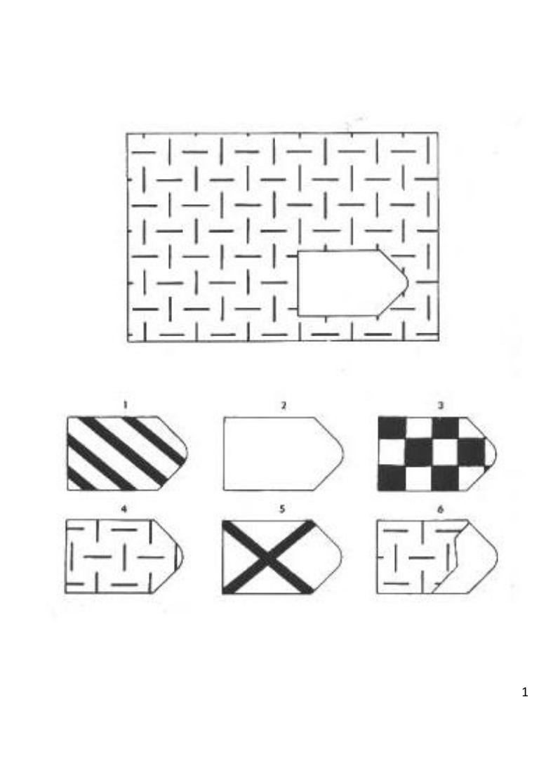
If you want to continue to the next step your son or daughter will be asked to wear an Actiwatch Mini (CamNTech, Cambridge, UK) on the non-dominant wrist continuously for five nights (from Sunday to Thursday night). After which, the Actiwatch will be returned to the researcher. The Actiwatch will measure sleep/wake patterns through movement using an accelerometer set in the small device. It will reveal information about the child’s sleep duration and sleep quality. The child can continue their daily activities
such as swimming as this small device is waterproof.

I will show you results of how your sleep works and will explain you the recordings of your sleep. You will get a scientific report back as thank you. | 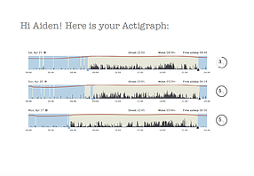
You will get £5 AMAZON voucher to thank you for your participation!

What are the possible benefits of this study?
There is a lack of firm understanding of the nature and prevalence of sleep difficulties in teens. This is particularly important for teens as we have very little understanding about their sleep. The study also hopes to raise awareness of the importance of sleep especially among teenagers with developmental disabilities.
What are the risks involved?
Nil

Is participation compulsory?
Participation is voluntary. Participants are free to withdraw from this study at any time prior to publication without penalty, prejudice, negative consequences, repercussion or disadvantage. The decision to withdraw from this study will be kept confidential. Upon withdrawal, all data obtained from the participants and associated with them will be erased and destroyed.

Will the data be confidential?
Confidentiality of all teenagers and parents and collected data will be protected. The identity of participants will not be used in the reporting of the research data nor in any intended publication of any sort, be it electronic or print media. All records containing personal information will remain confidential and no information, which could lead to identification of any individual, will be released.

Will there be any compensation?
The child will be given £5 and individual sleep certificate for their participation. Also, at the end of the study, parents will receive a brief report of their child’s sleep quality and quantity based on the Actiwatch findings.

Ethical Issues
This project has received ethical clearance from University College of London (UCL) Institute of Education Research Ethics Committee. If you have any queries about this research at any point in time, you can contact the corresponding principal investigator via email to georgia.pavlopoulou.14@ucl.ac.uk

If you wish to talk to an independent person about your concerns, questions can also be directed to University College of London Institute of Education Ethics Committee via email ioe.researchethics@ucl.ac.uk.

Signature
Your signature in the consent form attached indicates that you have read the information provided above.

Contact details of the main researcher
Georgia Pavlopoulou
georgia.pavlopoulou.14@ucl.ac.uk

Department of Psychology and Human Development, LiLAS Lab
25 Woburn Square, London WC1H 0AA
UCL Institute of Education

Please complete this consent form and return to your school or email it to : vasiliki.matella.17@ucl.ac.uk

Yes No

I agree to take part.

I agree for my child to take part.

I understand that if any of my child’s results are used in reports or presentations
will not be attributed to me.

I understand that I can withdraw from the project at any time, and that if I choose to do this, any data I have contributed will not be used

I understand that I can contact the main researcher (Georgia Pavlopoulou) at any time.

I understand that the results will not be shared with the school.

I have discussed the information sheet with my son/daughter

I want to complete the online survey

I want to complete the missing puzzle test

I want to complete sleep diary and actigraphy for 7 days/nights

Child’s Name ______________________

Parent’s/ Caregiver’s Name _______________________

Home address (if you have indicated interest) __________________________________________________________

_________________________________________________________

Parent’s/ Caregiver’s Contact Number _________________________
(if you have indicated interest)

Parent’s/ Caregiver’s email (if you have indicated interest) _________________________

Signed _______________________ Date ____________________

