A Level
Art
Course Booklet
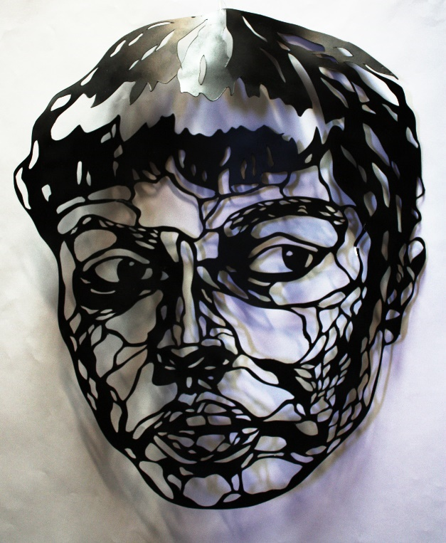
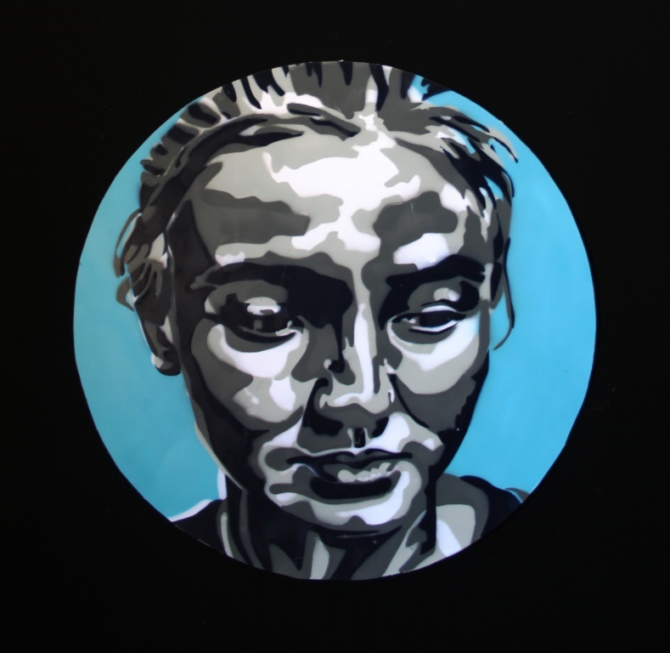

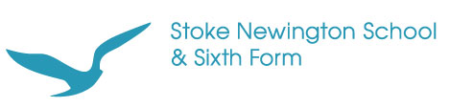

A Level Art at Stoke Newington School

Welcome to A Level Art at Stoke Newington. This mini guide is intended to introduce you to the Art Department at Stoke Newington School and tell you a little more about what we do here. The course’s ethos enables you to develop to your maximum potential. All staff working in the art department are themselves practicing artists.

Why Choose Stoke Newington School

- You will be able to work in one of the most exciting Art Departments in North London, praised by Ofsted and the Exam Board for the diversity and quality of the students’ work.

- There is an exciting visits programme to London Galleries and museums planned and outside workshops in some of the best Art Colleges.

- You will have a dedicated sixth form studio space with a well-resourced library of books.

We are here to help you get the most out of the course. If there is anything we can do to help then please ask.

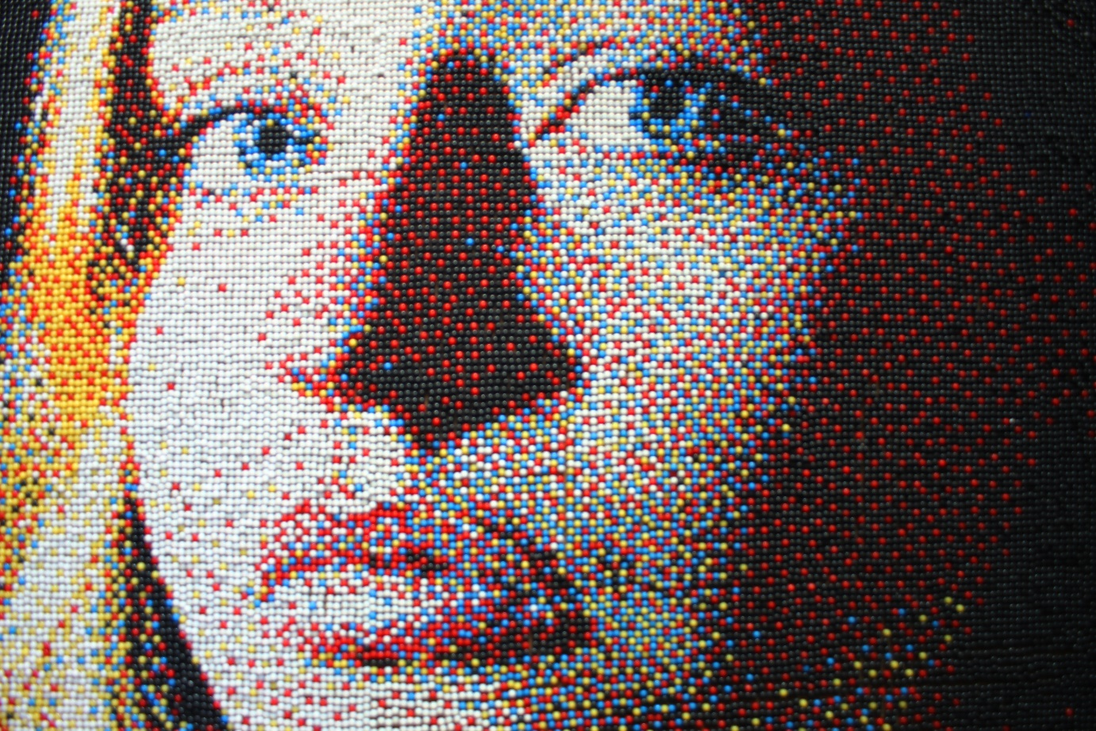

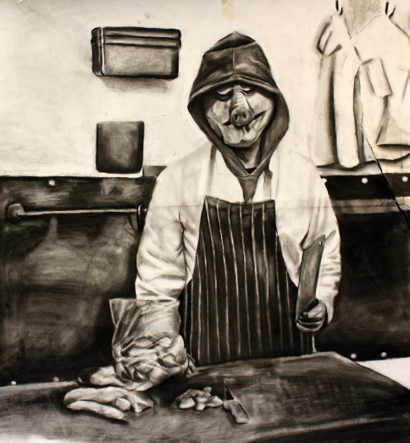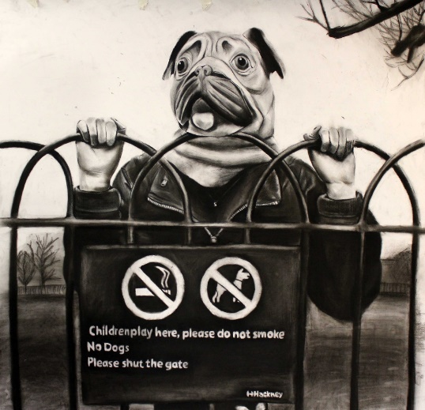

Art A Level Summer Assignment

We expect you to produce a project over the summer – this will give us a chance to understand how you work, what artists you like and help us to plan the lessons more effectively for you.

The theme is Transformation for Component 1.

Construct a still life arrangement that is adventurous and visually challenging. Vary the colours, surface qualities and structural features of the objects you use – they could be organic or man-made. Look for unusual viewpoints. Imagine what ordinary objects might look like in another reality. A transformation of an object that might become more fragmented turned inside out or simply changes shape.

Current exhibitions that relate to Transformation:

‘Lee Krasner: Living Colour’, Barbican Art Gallery, 30th May – 1st Sept 2019
‘Olafur Eliasson: In Real Life’, Tate Modern, 11th July 2019 – 5th Jan 2020

See the Tate Modern’s displays in the Boiler House and the Tanks, many of which relate to Transformation.

Produce 3 A2 sketches using the following materials or a combination of them:
Charcoal/pen/pencil/chalk; Paint (watercolour or acrylic); torn paper; and oil pastel

Then produce 3 studies of artists who work with objects and whose work relates to transformation. You should try to visit the Tate galleries Modern and Britain to view the work first hand and draw in the gallery.

Artists you may wish to study are:
Jacques Lipchitz, Alberto Giacometti, Tony Cragg, Louise Bourgeois, Cornelia Parker, Naum Gabo, Jeff Koons, Peter Fischli & David Weiss, Anselm Kiefer, Henri Gardier, Juan Gris, Jenny Saville, Lucian Freud, Marlene Dumas, Rebecca Horn

You must be prepared to talk about your work in the first week back when you will be asked to display the project for a group critique. Good luck.

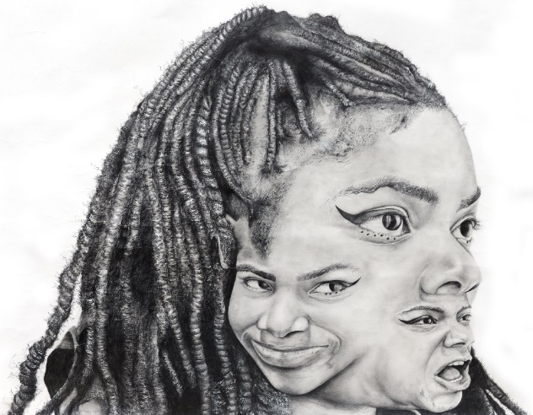

Requirements/Organisation

For the course there are numbers of items that it is vital to have:

A1 Portfolio
Set of watercolours and brushes (no’s 5,8 and 12)
Box of chalks and oil pastels
A2 and A3 sketchbooks
A range of soft pencils
Two glue sticks (Pritt)
Aerosol fixative
Willow charcoal (assorted sizes)
Eraser and putty rubber

In A Level Art the work is very self-motivated. Teachers will give you a weekly tutorial giving you advice and direction with your work and it is therefore vital that you bring all work and sketchbook to each lesson so that this can take place.

The Course
The purpose of this course is to develop your ability to appreciate the visual world and to respond in a personal and creative way. It will encourage you to:
- Question all preconceived notions of art and personal ability.
- Encourage you to trust your creative instincts.
- Help you to express your ideas and feelings through the controlled use of a broad range of materials and techniques.
- Help you to investigate and relate to all the evolutionary processes that are inherent in the development of Art and Design.
- Encourage you to articulate issues relating to the work of other artists from a variety of cultures, past and present.
The A Level course is tightly structured at Stoke Newington School. It is a linear course.
Entry requirements: At least grade 4 in both Art and English language GCSE. Students will also need to demonstrate an interest in and a commitment to the subject and complete a summer assignment. This is a two-year course.
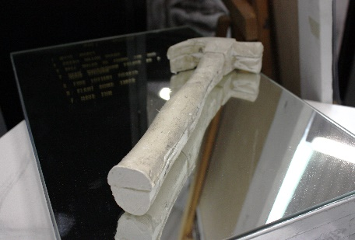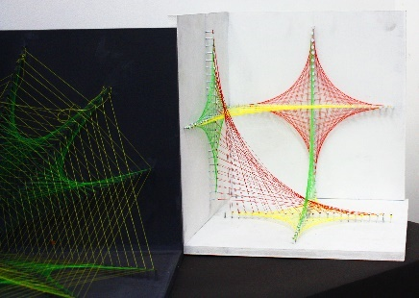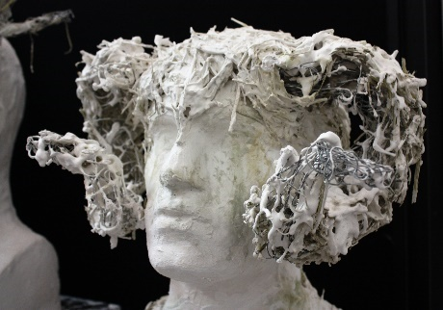

Component 1 (Sept 2019 – Feb 2021): Personal Investigation – 60% of the total qualification. This component allows students opportunities to generate and develop ideas, research primary and contextual sources, record practical and written observations, experiment with media and processes, and refine ideas towards producing personal resolved outcome(s). There are three major elements: Supporting studies, practical work, and a personal study.
Supporting studies and practical work will comprise a portfolio of development work and outcomes based on themes and ideas developed from both given and personal starting points. We deliver structured workshops at the start of the course to build skills and confidence in the formal elements of drawing, painting, print making, digital media and sculpture. The strength of our course is linking to professional practice and the wide range of independence and creative skills that students demonstrate. We also expect students to attend exhibitions in their own time and offer the opportunity of a trip to New York during the 2 year course. The Personal Study will be evidenced through critical written communication showing contextual research and understanding in a minimum 1000 words of continuous prose, which may contain integrated images.
Component 2 (Feb 2019 – May 2021): Externally Set Assignment - 40% of the total qualification: This represents the culmination of the A level course. This component incorporates two major elements: Preparatory studies and the 15-hour period of sustained focus. The assignment will be externally set and consist of one broad-based theme and suggested starting points, released on 1st February of the second year. Students submit supporting studies and practical outcome(s) in response to the given theme. Supporting studies will consist of annotation, research and compiled contextual references, practical exploration of materials and techniques, recording from primary sources and developmental stages of practical work leading to refined practical outcomes.

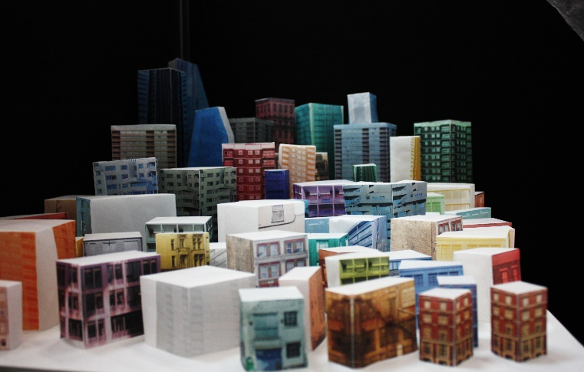

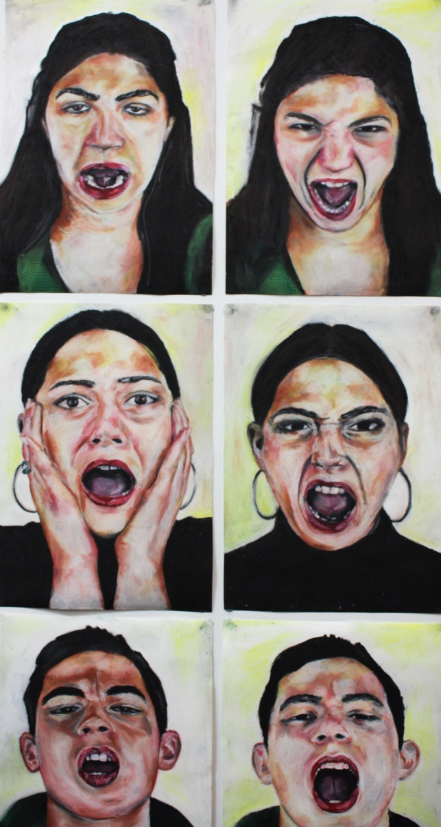
The Art department has very high expectations of every student and believes that everyone can be an artist and that every student has the potential to produce work of the highest standard. There are many careers in art, craft and design. Most require further study at an art college or university, with most students taking a one-year Foundation Course before applying for degree courses in more specialist areas of art and design. Careers where it is useful to have studied art include advertising, marketing, design, architecture, publishing, media, conservation, restoration, illustration, web design, sculpture, painting and print making and other professions looking for creative people.
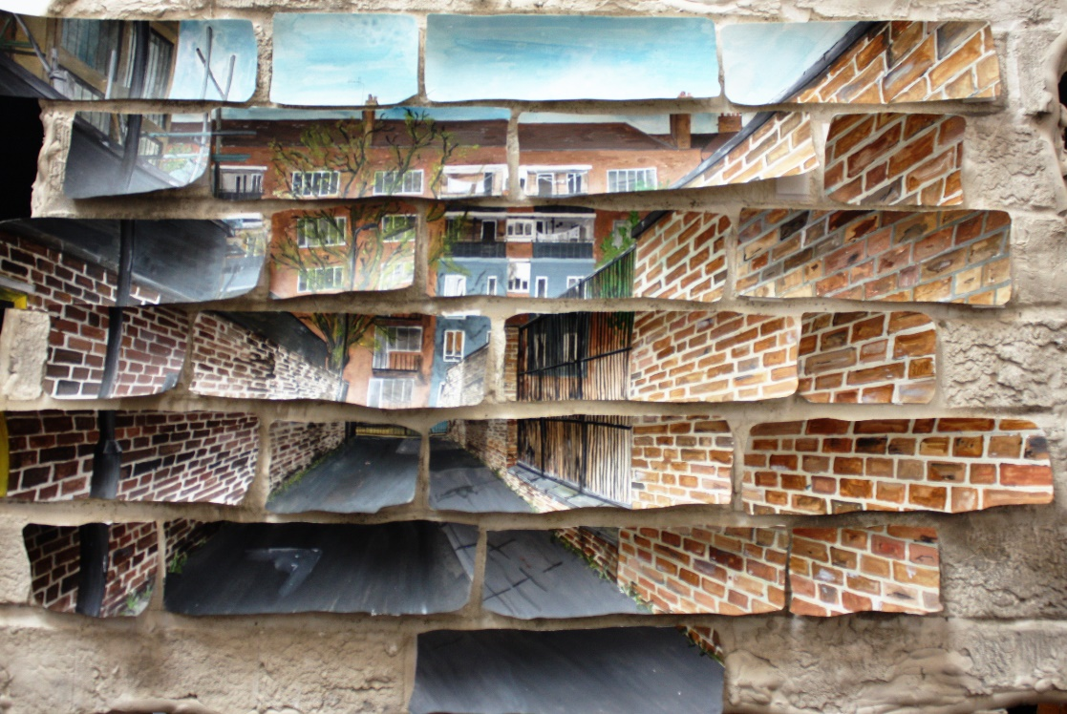

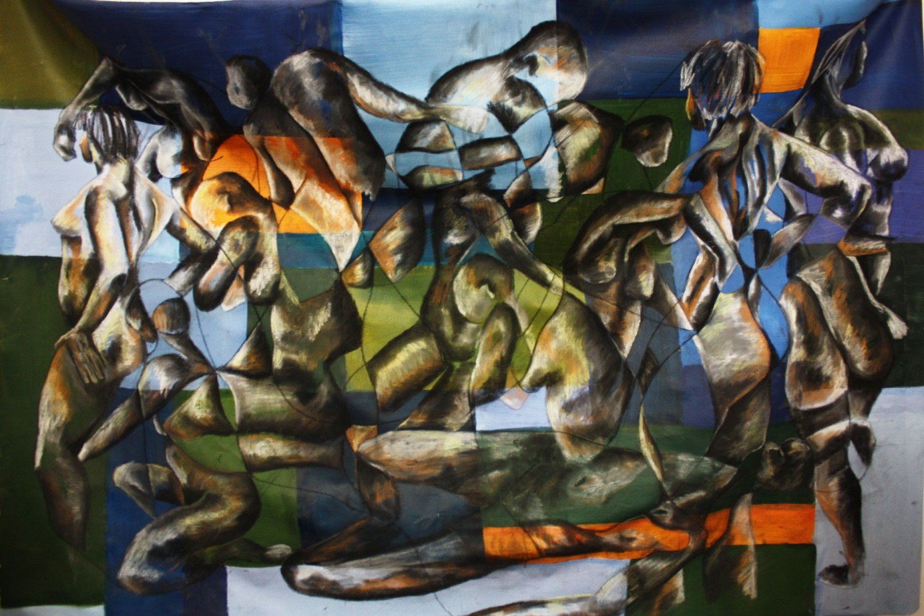

Assessment
Component 1 and Component 2 for A Level Art are marked in four assessment objectives, each worth 25% of each of the whole part.

AO1 | Develop ideas through sustained and focussed investigations informed by contextual and other sources, demonstrating analytical and critical understanding.
AO2 | Explore and select appropriate resources, media, materials, techniques and processes, reviewing and refining their ideas as the work develops.
AO3 | Record ideas, observations and insights relevant to intentions, reflecting critically on work and progress.
AO4 | Present a personal, and meaningful response that realises intentions and where appropriate, makes connections between visual, and other elements.

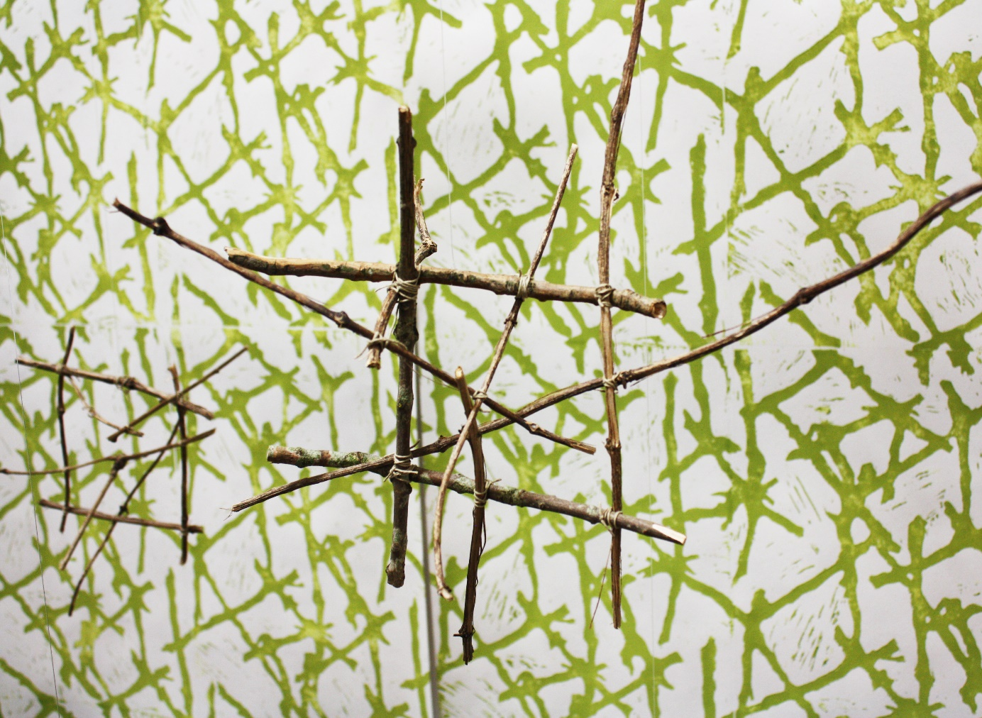

New York City 2020

The Art and Photography department will again be hoping to run the highly successful visit to New York City in 2020. During the trip we visit world famous galleries and sights including MoMA, The Guggenheim, The Metropolitan Museum of Art, Times Square, the Empire State Building and the Statue of Liberty. Students have found this trip to be immensely inspirational and extremely valuable for supporting their studies in A Level Art.

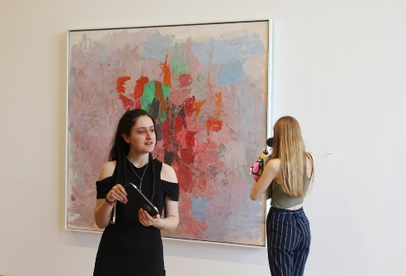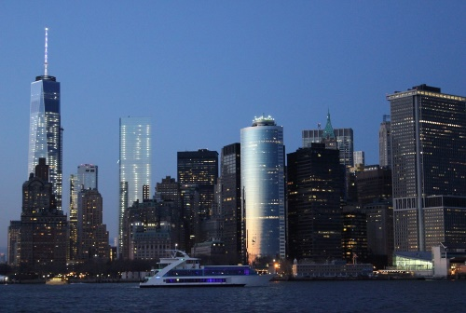
Contact
Should you have any questions about the course, entry requirements or content please find me in the art rooms, call 0207 241 9609 or send an email to Audrey.Mullins@sns.hackney.sch.uk
Ms Mullins, Head of Art Department

