Modern Technology in Sport

Activity 1: Development of equipment and facilities and their effect on participation in sport
- Based on this image, identify two technological developments to sports facilities and explain how they could increase participation in sport.
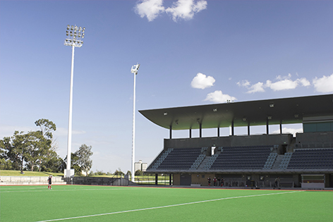
1.

2.

- For the following technological innovations, describe how they might affect participation in sport and physical activities

- Running Blades
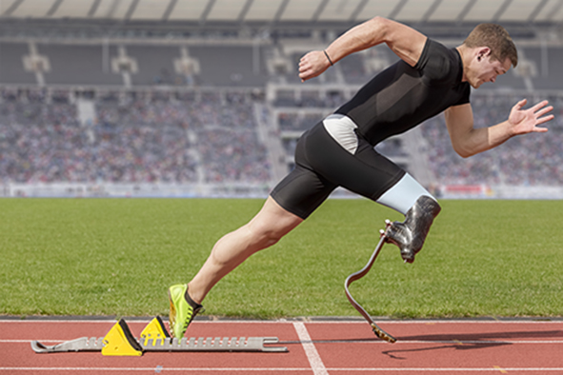

- Safety Clothing and Equipment

- Lawn Darts (modified sports equipment)
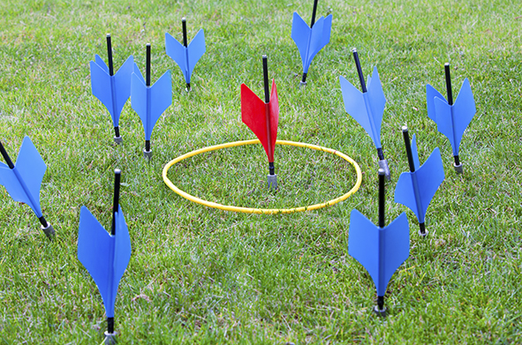

- Segways
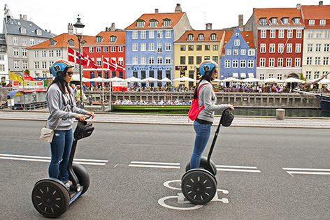

Activity 2: The effect of technology on participation in sport and physical activity
Fitness apps, usually based on smartphone technology, are seen
as one way of increasing participation in sport.

- Complete the table of benefits and limitations of fitness apps as
a means of improving participation in sport:

Benefits | Limitations

- Group debate: In small groups, debate the following motion:

‘Computer games decrease participation in sport’

Activity 3: Technology and its effects on fairness and entertainment in sport
Sports such as Rugby Union, Cricket and American Football have introduced Television Match Officials (TMOs) to adjudicate decisions when the on-field referee is uncertain.

Read the following example report:
‘Leading sports sociologists have generated fascinating findings on the use of video replay technology to help match officials in sport. Video referral technologies, as used by ‘third umpires’ in cricket and ‘television match officials (TMO’s) in rugby have been welcomed by some NGB’s as making their sports fairer. However, opinion is divided on whether such systems have changed sports for the better, either for performers or spectators.

While surveys have shown that most players like the improved accuracy that comes from video referral technology, several players have expressed concerns when interviewed. Professional rugby players have expressed frustration that they have scored tries that the referee has initially given, but informal requests from opposition players to use the TMO has led to the decision being overturned. Players in away matches have noticed that in stadia where there are giant screens, replays of foul play or refereeing controversies may lead to the crowd influencing officials.

Other players are concerned that with more and more decisions being referred to video officials, the flow of the game is impeded by the sheer number of stoppages. In rugby, close decisions sometimes take up to five minutes to decide. In cricket, video referral technologies have occasionally been wrong, affecting the outcome of matches, leagues and tournaments.
For spectators, opinion on the use of video replays for officiating is similarly mixed. In cricket, teams can decide which technologies are used and which are not, which leads to inconsistency and disagreement across the sport. Given that video replay technologies are expensive, the way professional sport if refereed becomes very different from grass-roots sport.

Overall, as much as spectators like fairness, they also like to be entertained. Video replays provide drama and debate, but if they disrupt gameplay, is it worth it? While some welcome the influence of these innovations, some long to return to the days when the referee’s decision was final.’

- Complete the table of arguments for and against the use of TMO’s in sport:
For | Against

- Compare your answers with a partner, and add theirs to your table.

- Using the information in the table and your own knowledge, write a short essay on the following question:

‘Television match officials have a positive impact on sport for spectators’

