Starting A-Level Economics in Year 12 – Due date 3rd September 2019
Hope you are looking forward to starting a proper Economics course in September. Much of the work you will do will involve you analysing real life current issues affecting households, business and society as a whole. The government will have to make many key decisions in the next few years which may have a profound effect on people`s standards of living.
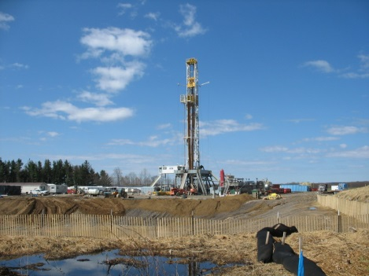
Here are a few examples of these decisions, perhaps have a chat with parents and relatives about these issues but try to develop your own opinions which you can justify!
Should we build a third runway at Heathrow airport?

MY response: (say Yes or No and explain why):

Should the government be investing in fracking for shale gas?

MY response:

What should government do to make houses affordable?

MY response:

MY response:
Should the British government spend more than 0.7% of GDP to help poor countries?

A CASE STUDY: HS2
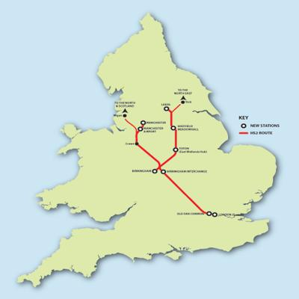
HS2 is the high-speed rail link between London and Birmingham and extended to Manchester. This hasn`t been built yet but the government would like to start work by 2015. Unlike most of Europe Britain`s railways are not that fast. the government believes that having a high-speed link between Britain`s 3 largest cities will make it easier for businesses to sell products throughout Britain. It will also create jobs and make it easier to trade with Europe as we will now have a high-speed railway from Manchester to Paris and the heart of Europe.
However, building the railway line will cause much disruption, houses may have to be knocked down, cemeteries disturbed and areas of wildlife would be displaced. Some people also say that it would cost too much to build and the rail fares would be too expensive. There is already a fierce campaign against HS2 run by environmentalists, local residents and politicians.
Your task is to write a short report of between 500 and 750 words with the following title:
ASSESS THE ECONOMIC ARGUMENTS FOR AND AGAINST BUILDING HS2

You should use the sources below to examine the advantages and disadvantages to Britain of building the railway. Try to arrive at a conclusion! Enjoy!
Sources (use any others that you find helpful!)
- http://www.hs2.org.uk/ - government website in favour of HS2
- http://stophs2.org/ - the campaign against
- Newsround http://www.bbc.co.uk/newsround/21231575
- BBC website
- The Guardian search for HS2
- 12 arguments for and against: http://www.bbc.co.uk/news/magazine-24159571
- Good channel 4 report: https://www.youtube.com/watch?v=LVhCiRvNDTg&safe=active

