Economics of the Crisis - Policies to avoid a depression

Please follow the link to access the videos needed for each question.

https://www.tutor2u.net/economics/reference/economics-of-the-crisis-policies-to-avoid-a-depression-head-start-in-a-level-economics

- Watch ‘The Economic Crisis deepens’ - The UK will definitely have a recession as economic figures from the first quarter of 2020 saw a 2% fall in GDP, and will fall far further in the 2nd quarter. What do you think has to happen in the UK in order for us NOT to have a depression?

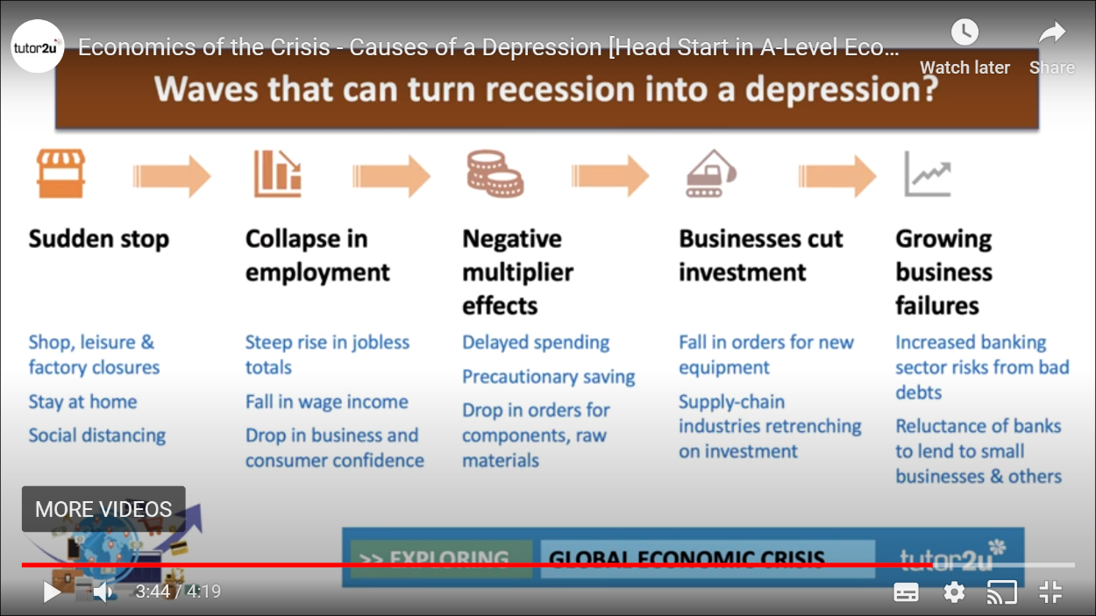
- Watch ‘Causes of a depression’ video - Geoff talks about the five waves that turn a recession into a depression -

At the centre of his explanation is a concept called the ‘negative multiplier effect’. Explain your understanding of what this is and why it is so important for understanding why a recession can turn into a depression?

- Watch ‘What might Keynes say’ video - explain why John Maynard Keynes insisted that the Government must step in to stop a depression

- Watch ‘The UK Government response’ - Geoff talks about fiscal policy and monetary policy.

What’s your understanding of the difference between fiscal and monetary policy?
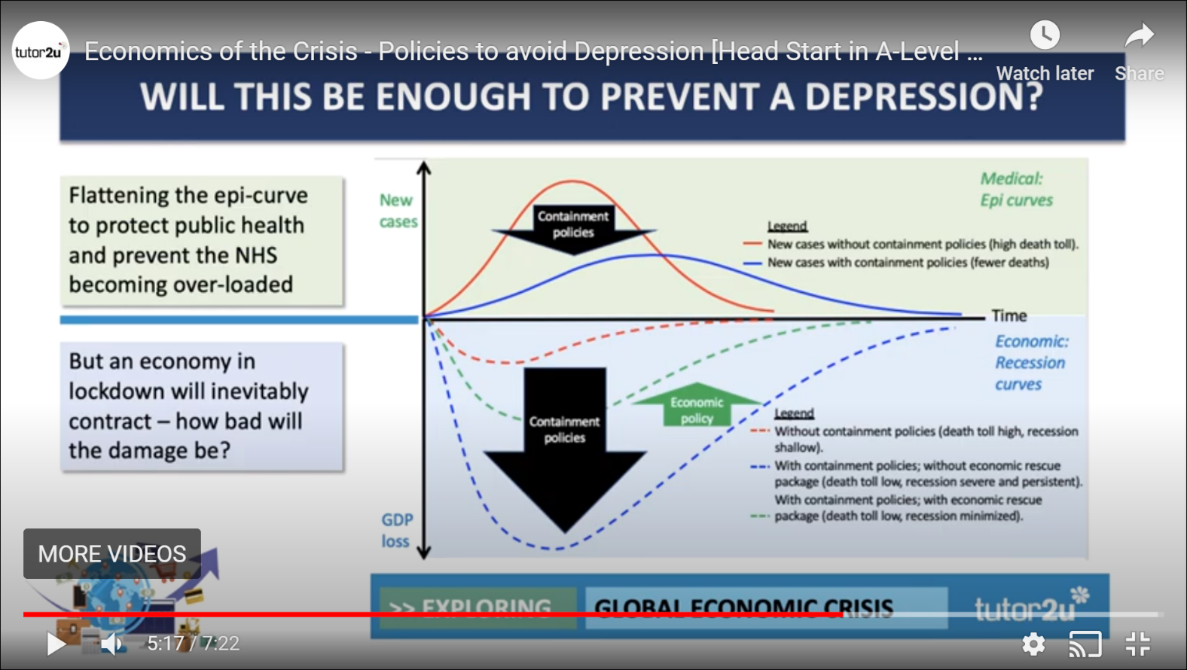

Explain how this graph explains the trade-off the Government needs to make between containment of the virus and containment of the economic downturn?

- Watch the video clip - U.S. unemployment hits highest level since Great Depression - in this, they discuss an interesting concept - that whilst unemployment has risen, wages are also rising - why is this and what does it tell us about how the interaction of supply and demand of labour can affect wages?

- Why is it so difficult to ‘start an economy back up again’ once it locks down?

- The interviewee talks about why ‘credit risk’ is so important - which is what happens if people cannot pay back their debts (mortgages or loans) - is there anything a Government can do about that?

- Watch the video - Martin Wolf - Coronavirus could be worst economic crisis since Great Depression - what’s the biggest difference between this pandemic crisis and the 2008-2009 Financial crisis that makes this crisis more serious for the global economy?

- At the end, Wolf suggest that our democratic systems might not survive unless we do what?

