Politics - Transition Task 5 - The Prime Minister and his Cabinet
In the Government of the UK, the Cabinet is a group of people led and chosen by the Prime Minister who are the main decision-makers in the British government. People in the cabinet have to be members of either the House of Commons or the House of Lords.
Can you identify the ones below? Some are very new to the job……
Find missing pics if you can and insert below… | Name /Role  and short explanation of responsibility…
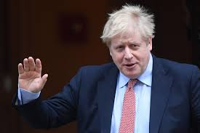
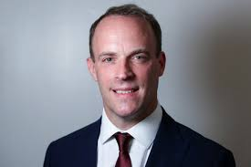
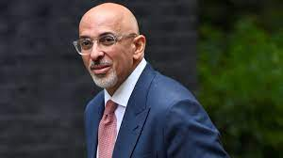
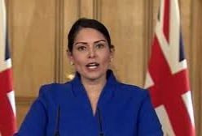
 | Health Secretary
 | Defence Secretary
 | Education Secretary
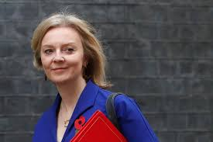
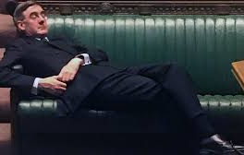
 | Culture Secretary
 | Secretary for Work and Pensions
 | Justice Secretary
 | Environment Secretary
 | Transport Secretary

